**Angular Day03 Session02 Handson02**

**Reactive Form – New Component and Name Field Inclusion :**

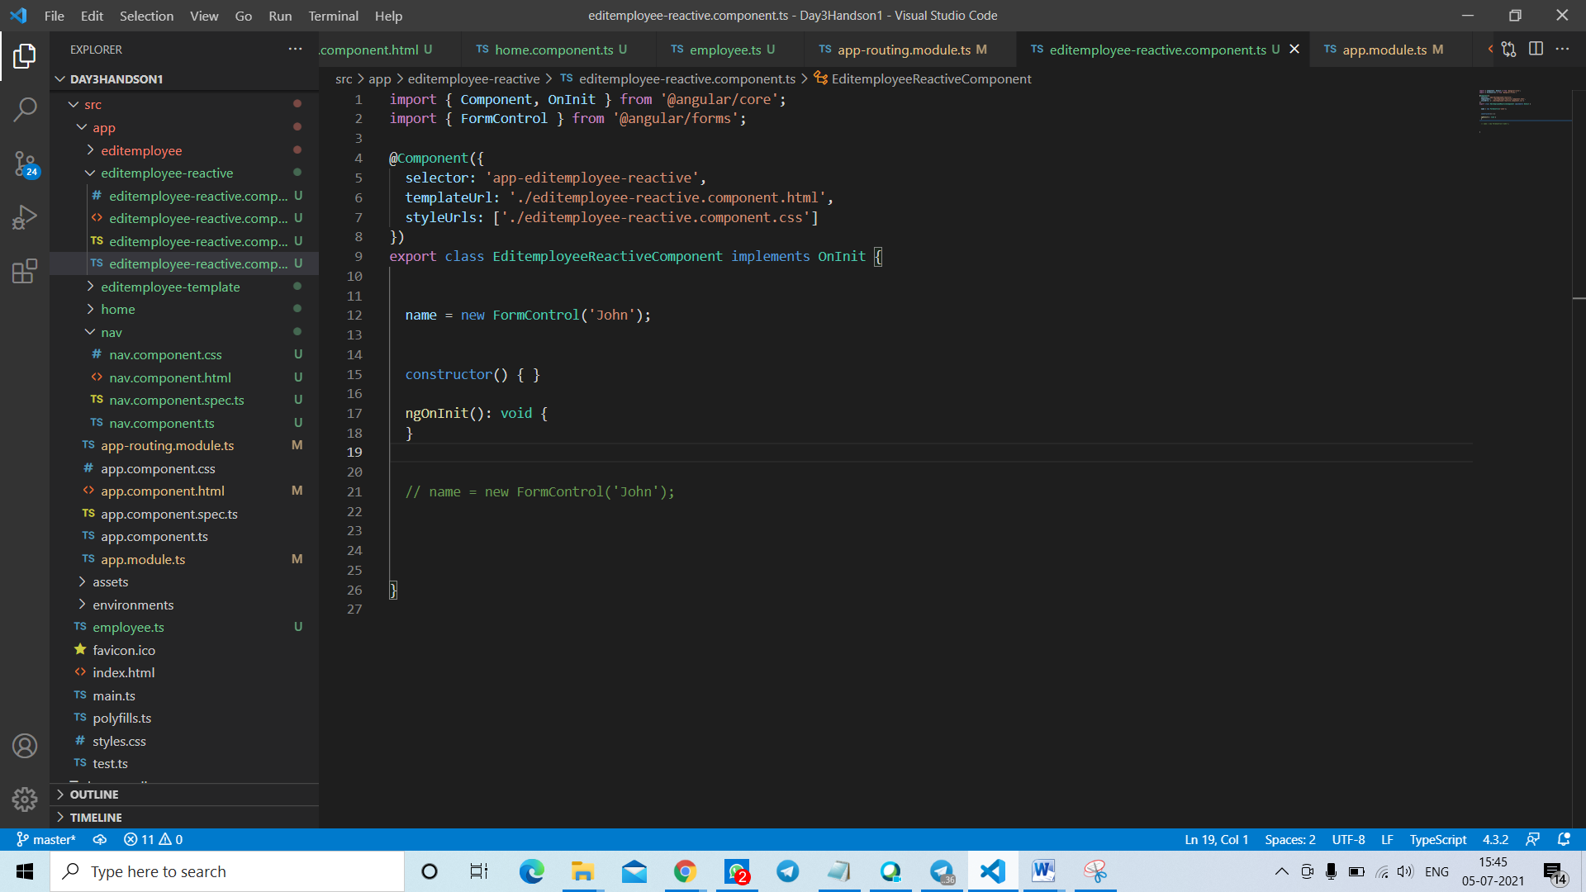

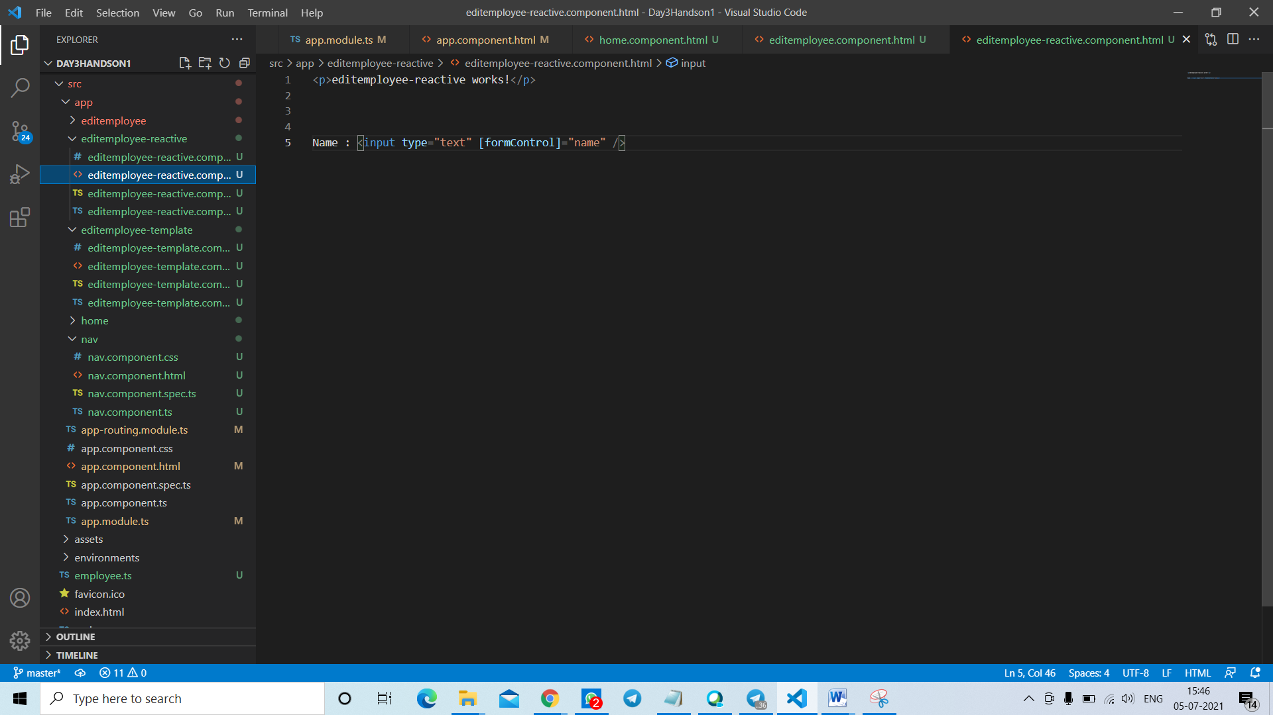

**Edit Employee Component Reactive Forms .ts Page :**

import { Component, OnInit } from '@angular/core';

import { FormControl } from '@angular/forms';

import { employee } from 'src/employee';

import {FormGroup, Validators } from '@angular/forms'

@Component({

  selector: 'app-editemployee-reactive',

  templateUrl: './editemployee-reactive.component.html',

  styleUrls: ['./editemployee-reactive.component.css']

})

// class Department {

//   id : number = 0;

//   name : string = "";

//   departments = [{}];

// }

export class EditemployeeReactiveComponent{

  empid = "100";

  empname = "Dinesh Balaji";

  // _department = new FormControl(Department);

  // departments = [

  //   {id:1, name:"Payroll"},

  //   {id:2, name:"HR"},

  //   {id:3, name:"Production"},

  // ]

  name = new FormControl(this.empname);

  empForm = new FormGroup({

    'name' : new FormControl(this.empname, [

      Validators.required,

      Validators.minLength(4),

      Validators.maxLength(20),

    ])

  });

  empformname : any;

  getName()

  {

    return this.empForm.get('name');

  }

  constructor() { }

  ngOnInit(): void {

  }

  // name = new FormControl('John');

}

------------------------------------------------------------------------------

**Edit Employee Component ReactiveForms .html page :**

<p>editemployee-reactive works!</p>

Name : <input type="text" [formControl]="name" />

<!-- <div>

    <h3>Department</h3>

        <select formControlName="_department">

            <option *ngFor="let department of departments"

            [ngValue]="department"

            [selected]="department.id === employee.department.id" >

            {{department.name}}

            </option>

        </select>

</div> -->

**Output Screenshots :**

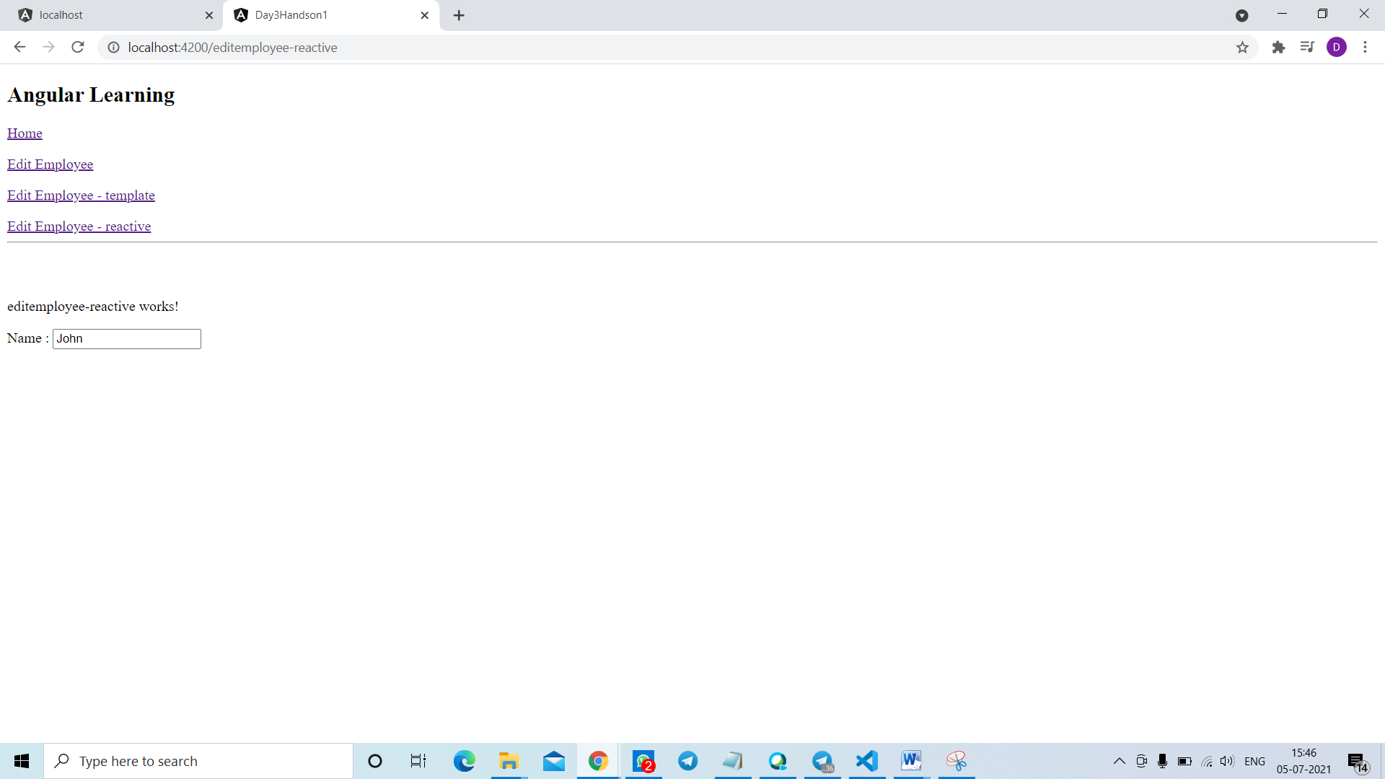

**Reactive Form – Include Salary, permanent and Department Fields :**

